TASK 1:

public class PrintName {  
 public static void main(String[] args) {  
 String name = "GREETINGS"; *// Replace "Your Name" with your actual name*  
 System.out.println(name);  
 }  
}

TASK 2:

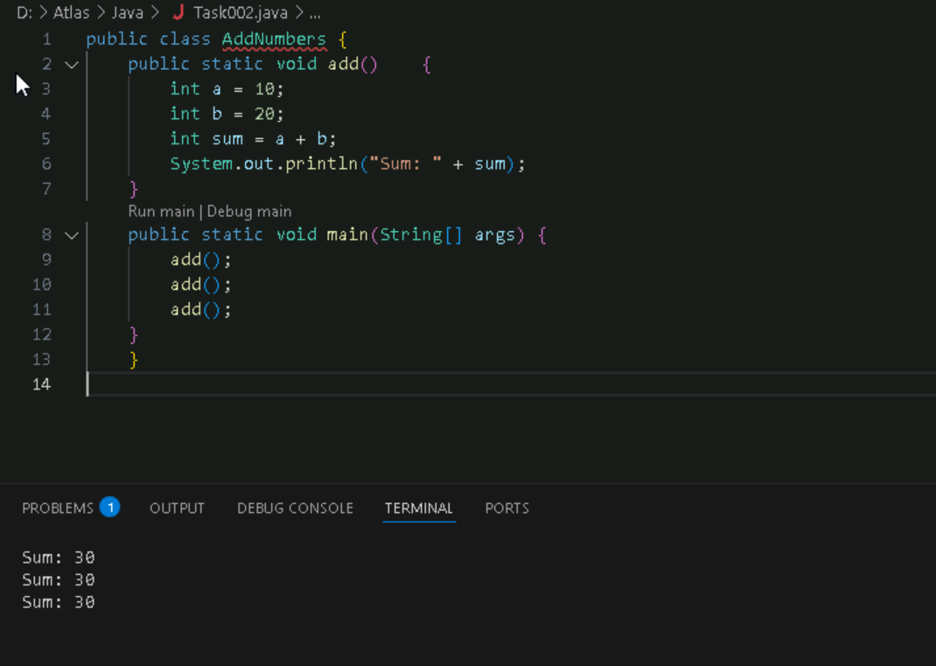

Task3:

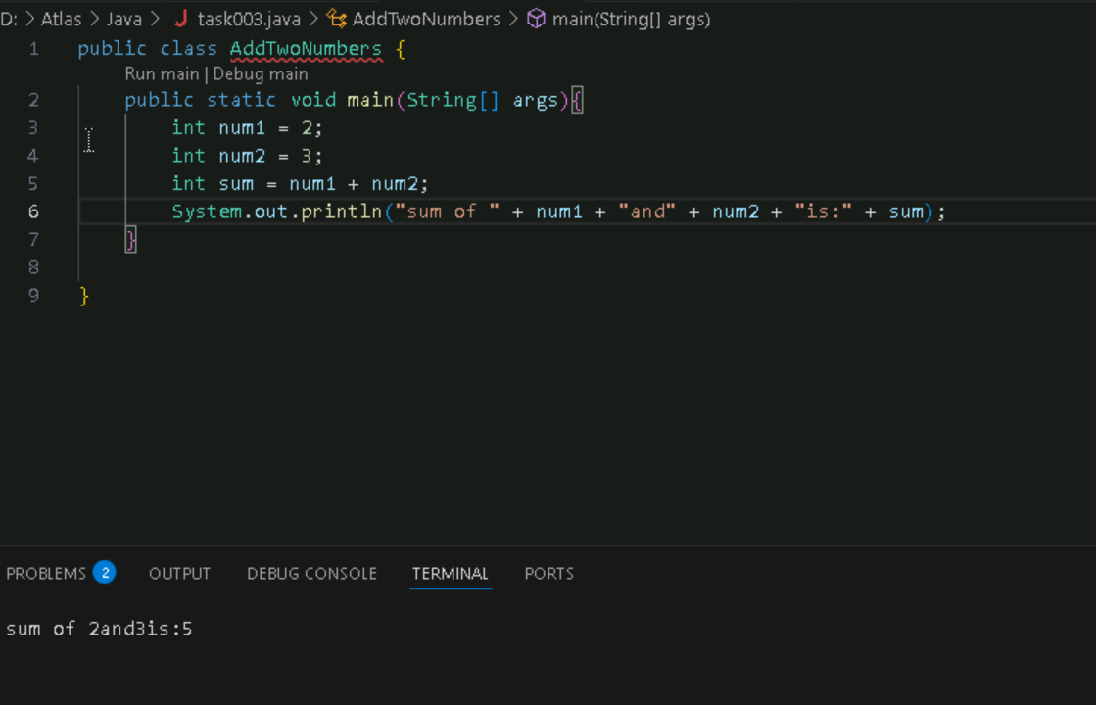

Task 4:

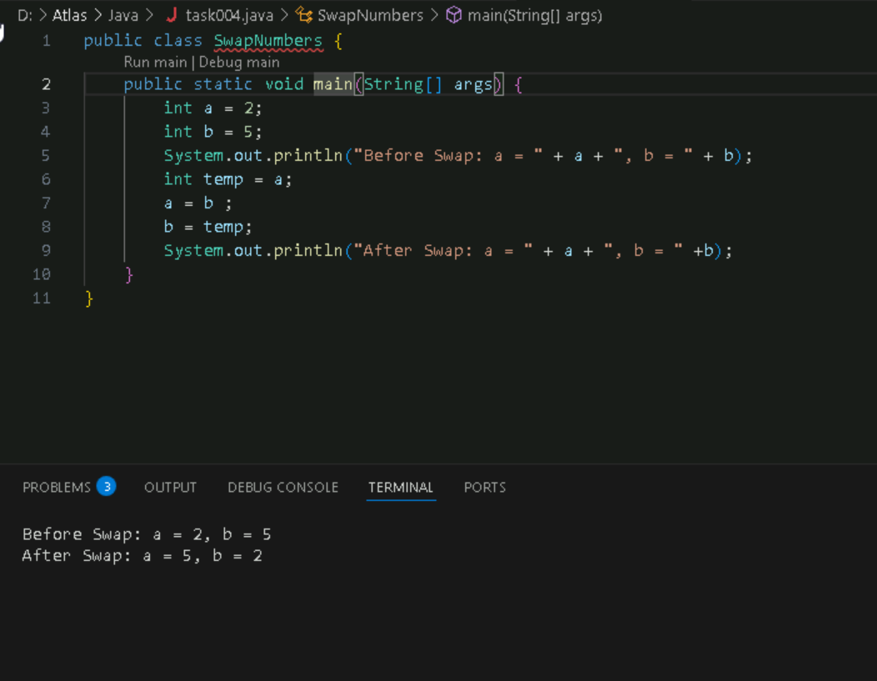

Task 5:

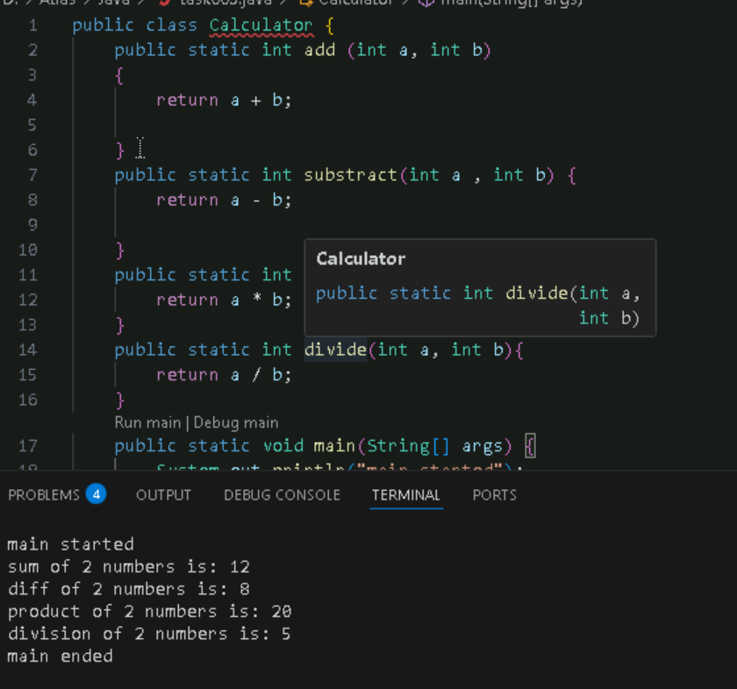

Task 6:

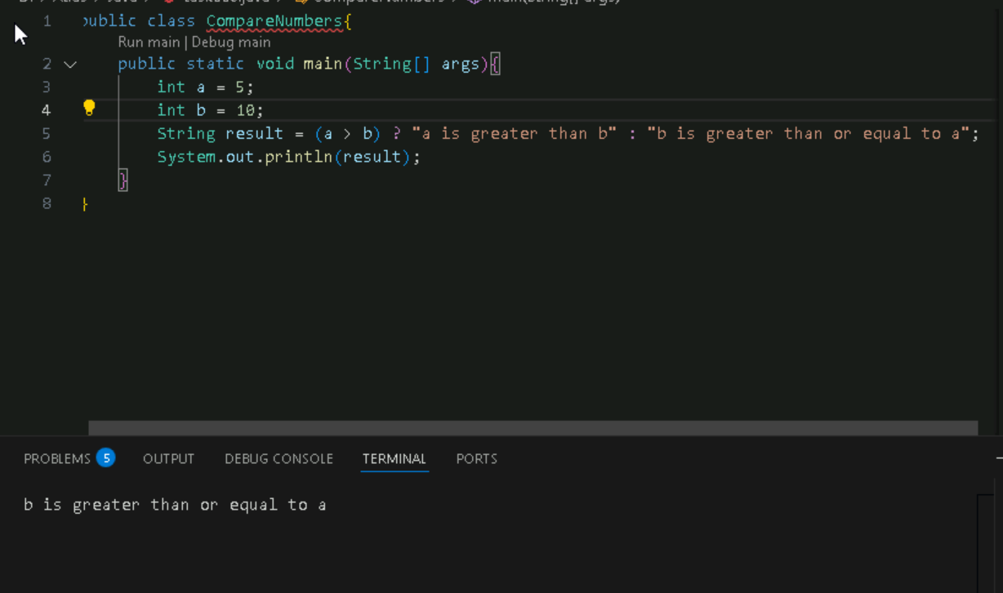

Task7:

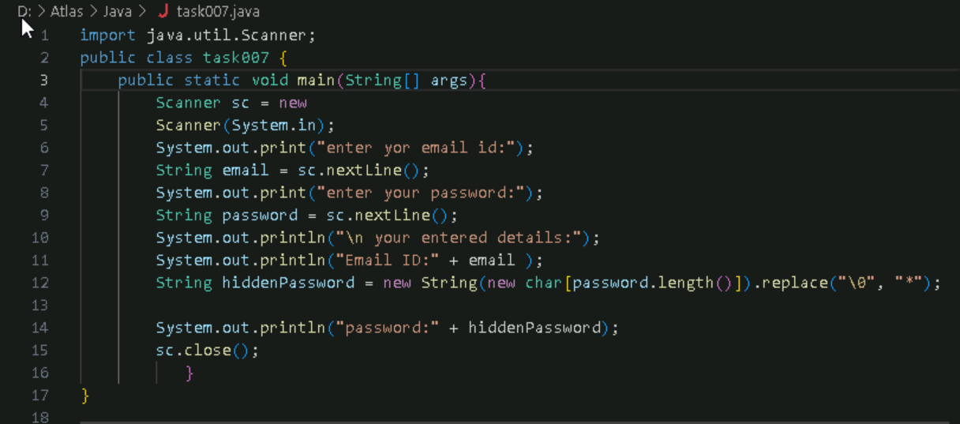

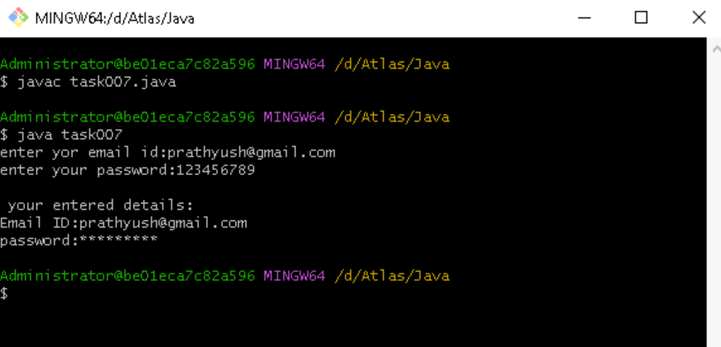

Task 8:

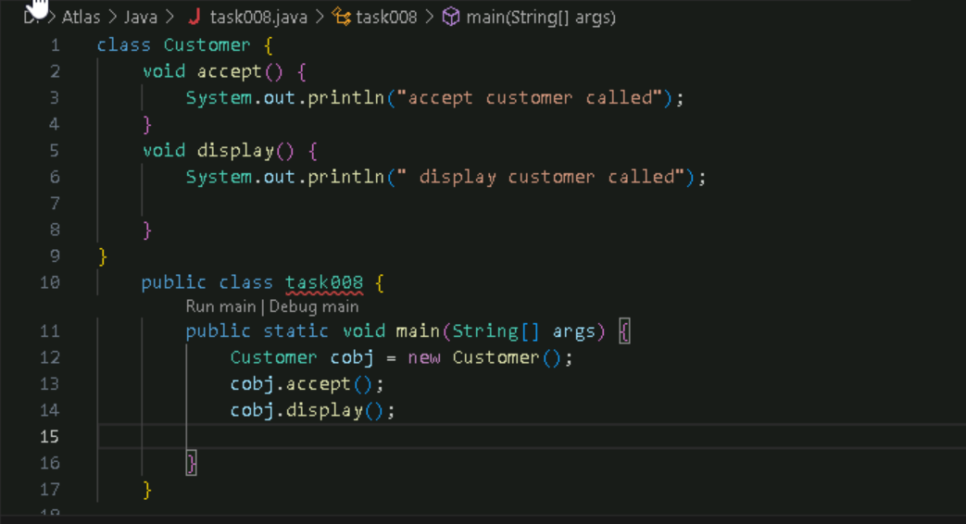

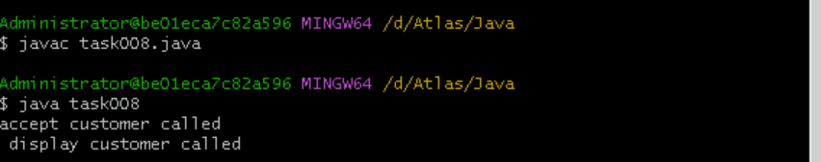

Task 9:

Task009:

Wap to check the greater of 2 numbers

Hint:

Use if else

If ( num1 > num2){

sout(“num1 is greater”);

}

Else {

sout(“num2 is greater”);

}

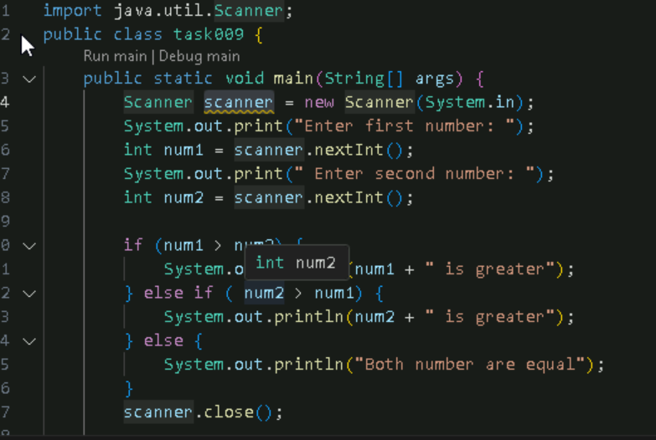

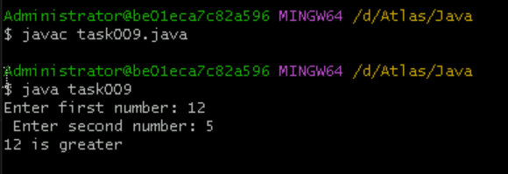

Task 10:

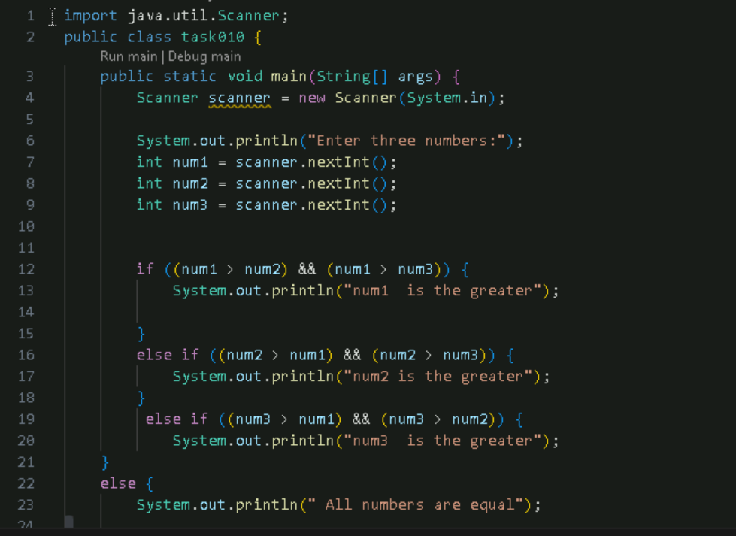

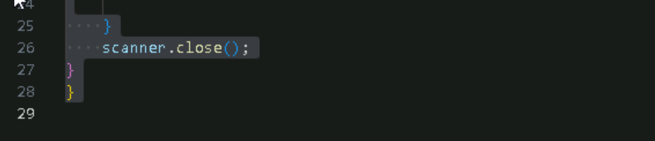

Output:

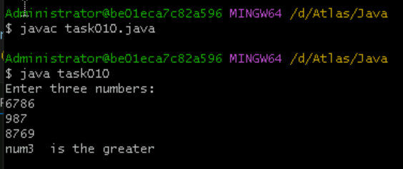

Task 11:

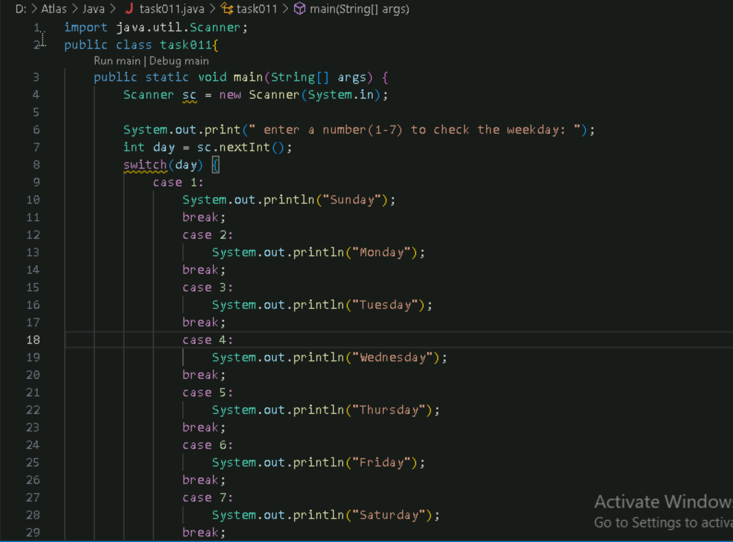

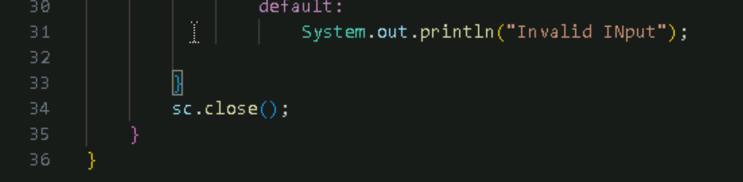

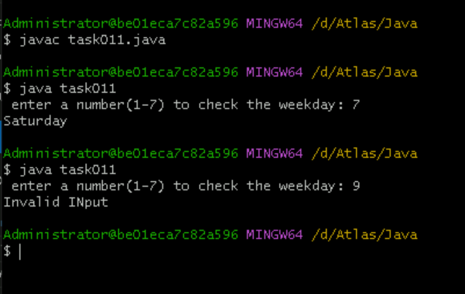

Task 012

Wap to check loginid and password validation

Hint use while loop

Scanner sc = new Scanner(System.in);

String loginid = “Prasunamba”

String pwd = “12345867”

Int Count = 0;

While (loginid == “Prasunamba” && pwd == “12345867”){

sout(“ you have logged in for  ”+ count++ +” times”);

sout(“enter ur login id and password”);

loginid = sc.NextLine();

pwd = sc.NextLine();

}

Do while also use 👍

Scanner sc = new Scanner(System.in);

String loginid = “Prasunamba”

String pwd = “12345867”

Int Count = 0;

do{

sout(“ you have logged in for  ”+ count++ +” times”);

sout(“enter ur login id and password”);

loginid = sc.NextLine();

pwd = sc.NextLine();

}While (loginid == “Prasunamba” && pwd == “12345867”);

sc.close();

While and do while loops - indefinite loops

For loop is definite…

For (initialization exp; condition exp; incre or decre exp)

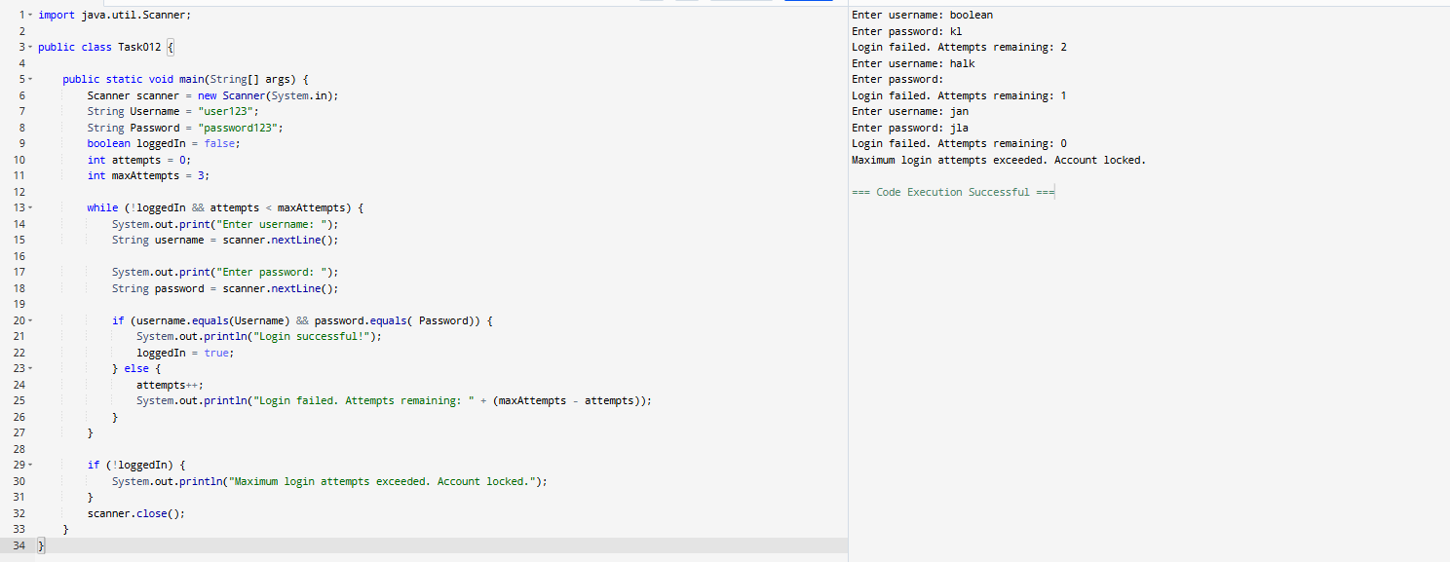

Task 13:

Wap to display numbers from 10 to 1 .. skip 7 and 5.

for(int i= 10; i >0; i–){

If ( i == 5 || i == 7)

Continue;

sout(i);

}

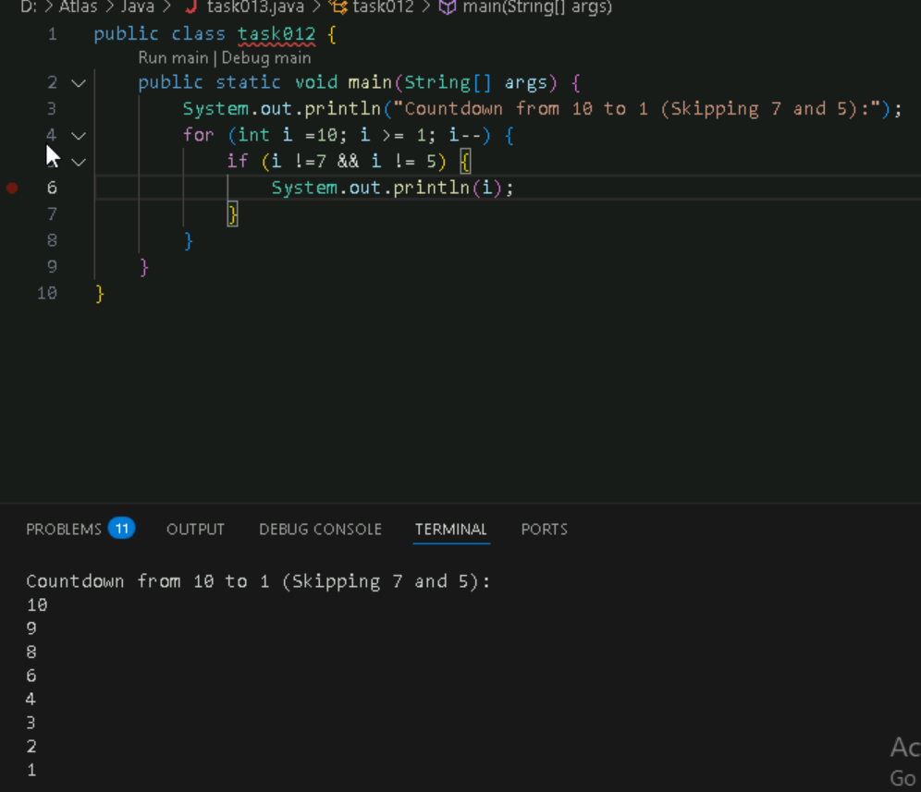

Task 14:

Arrays:

Try the below code and display the output…

Now play with it try to access arr of 5th index and see the output…and try to access arr of -1 index and see the output..

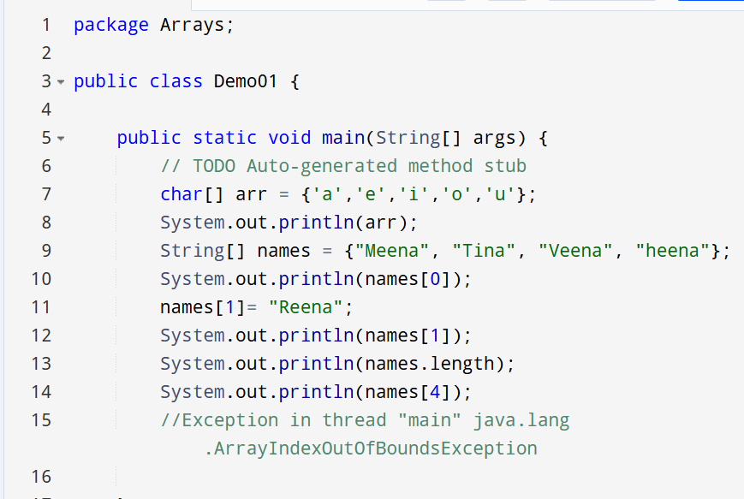

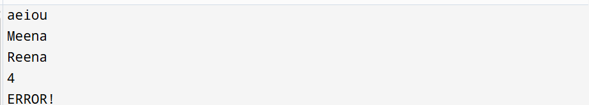

Task15:

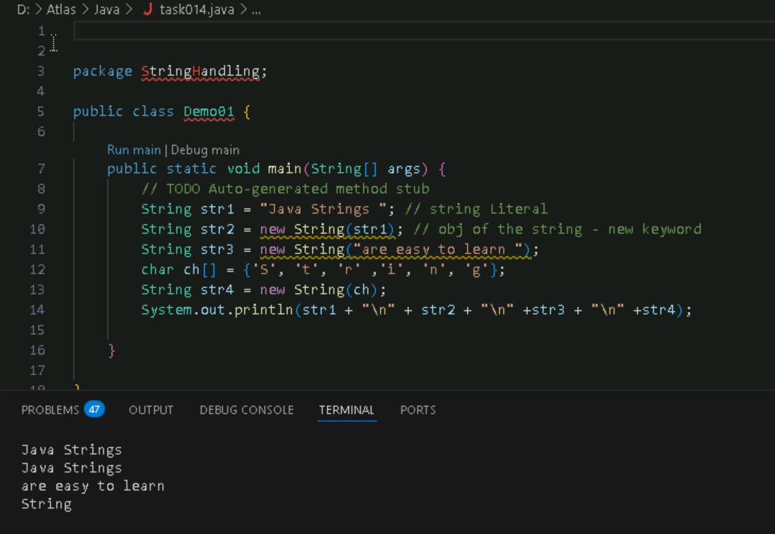

Task16:

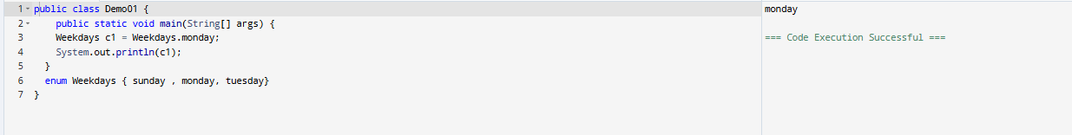

Task 17 task 18:

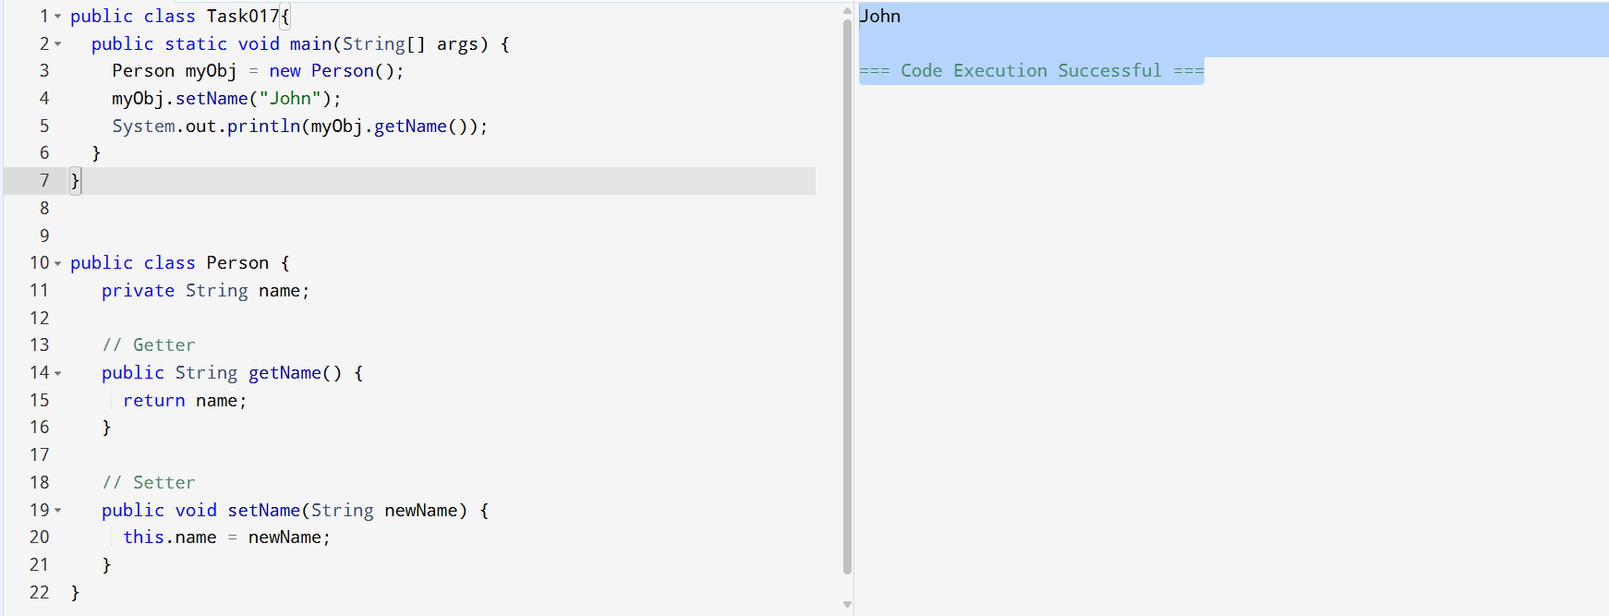

Task 20:

